**Sampling Procedure**

For each sampling event, two types of samples will be taken from each colony:

* Frozen sample (for *Nosema* and RNA virus testing): ¼ cup of bees put into a 50 mL falcon tube **on dry ice.**
* Wet sample (for *Varroa* counts): ¼ cup of bees preserved in ethanol (does not need to be refrigerated).

**Materials included:**

* Funnel
* White bin
* Measuring cup
* Plastic containers with 70% ethanol (for wet samples)
* 50 ml falcon tubes (for frozen samples)
* Datasheets
* ID stickers to be placed on each sample taken
* Stickers for dry ice shipping

**Materials you will need:**

* Dry ice in a large cooler (15-20 lbs per cooler)
* Packing tape
* Plastic sandwich bag(s) for datasheet

**Before sampling:**

* Identify the closest UPS and hours to ensure shipment of the dry ice samples the day they are collected.
* Hives should be numbered with sharpie. **Please use the same numbering scheme as the stickers provided**. Each hive will have a letter and are labeled 1-48. M=migratory, S=stationary (control), E=exposed.
* Fill containers (for wet samples) with ~70% ethanol.

**To make 70% ethanol:** Using a clean container or bucket, mix 7 parts ethanol with 3 parts water. Pour into containers. There should be enough ethanol to cover ¼ of bees. We estimate ½ full should be enough.

**During sampling for each colony:**

1. Write the colony ID on the datasheet. Place ID stickers on the frozen sample tube (green) and wet sample container. Note that the sticker sheets are grouped by sampling event.

2. Perform a hive inspection and fill out the datasheet. Follow BIP protocols to estimate # frames of bees and brood pattern.

3. Locate a frame from the brood chamber. Make sure the queen is not present.

4. Shake the bees from this frame into the white bin (**figures 1 and 2**).

5. For collection of frozen sample: Using the measuring cup and funnel, transfer a full scoop of bees into a 50 ml falcon tube. **Immediate place on dry ice.**

6. For collection of wet sample: Using the measuring cup and funnel, transfer another full scoop of bees into a plastic container containing ethanol. All bees should be completely submerged (**figure 3 and 4**). Be sure cap is screwed on tightly.

7. Repeat steps 1-7 for each colony sampled.

**Once all colonies are sampled:**

1. Place datasheets in plastic bag and ship with wet samples. Follow USPS rules for shipments containing ethanol.

2. Frozen samples on dry ice MUST be shipped overnight on the same day they were collected. Follow rules for shipments containing dry ice. Information about shipping with dry ice:

* Samples need to be shipped with either UPS or FedEX (not USPS)
* Samples shouldn’t be shipped later Wednesday (Tuesday is best)
* Fill the cooler up with dry ice (around 15-20 lbs.) to ensure there is enough to get everything to VT nice and cold. Fill empty space with styrofoam so samples are getting banged around during shipment.
* Container needs to be shipped with a dry ice sticker. We will send you some stickers but you should also be able to get some from the carrier.
* There will be a hazardous materials form that needs to be filled out with the carrier

**Filling out the Data sheet:**

Each data sheet has space for 16 hives (8 on front, 8 on back). At the top of the sheet, write the yard and date and circle the sampling event # and treatment group. For each colony, write the ID and circle the queen status. Use BIP’s protocols for Brood pattern (on a scale of 1-5) and # Frames of Bees. Put a check mark for each pathogen/pest found during visual inspections. Leave blank if the pest is absent.

The abbreviations are as follows:

AFB: American foul brood

EFB: European foul brood

PMS: parasitic mite syndrome

SBV: Sac brood virus

Snot: Snot brood

Black Shiny Bees: Black Shiny Bees

DWV: Deformed wing virus

Wax moths: Wax moths

Small beetles: Small hive beetles

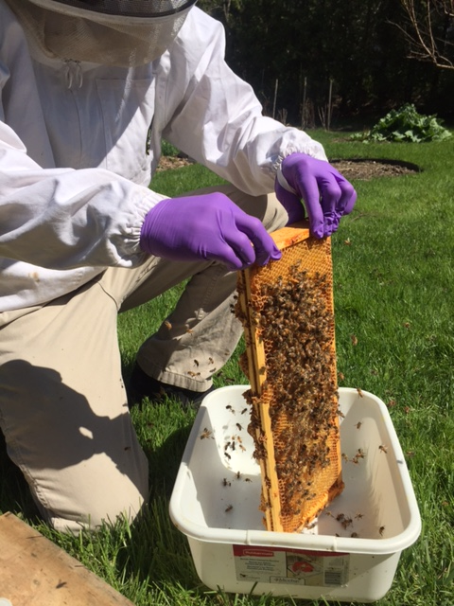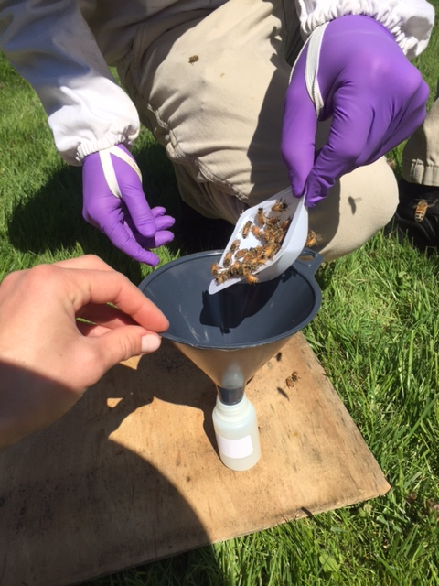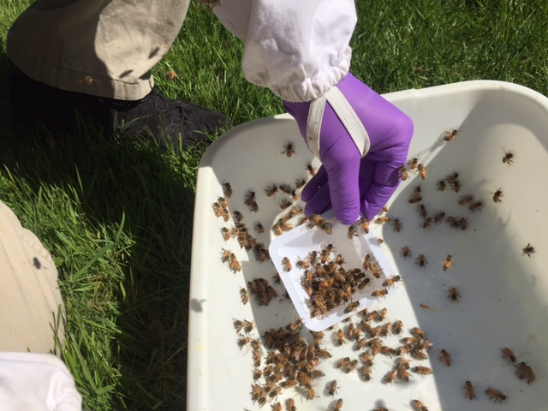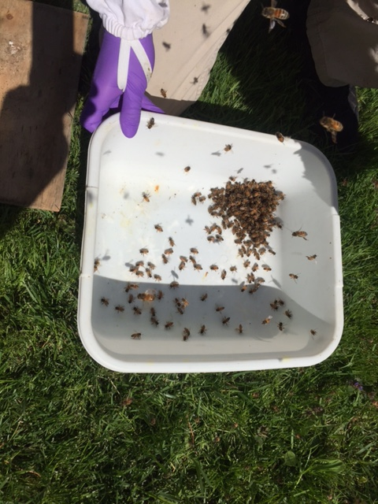

Figure 3. NOTE: You will have a metal measuring cup instead of plastic scoop.

Figure 1

Figure 4

Figure 2

Macintosh HD:Users:samanthaalger:Desktop:Migratory Beekeeping:Mig/Sta_Experiment_Schem .pdf

Figure 5. Schematic showing experimental design. Three sampling events occur during the experiment. Green boxes represent each group of 16 hives sampled during the specified sampling event. Slashed red boxes represent each group of 16 hives not sampled during that sampling event. Three experimental groups (Stationary Group [control], Migratory Group, and Exposed Group) are spread across three separate yards throughout the experiment: The Stationary Yard (where all groups begin and the Stationary Group remains for the duration of the experiment), the Migratory Holding Yard (where the Migratory Group is temporarily brought upon return from CA for sampling event 2), and the Exposed Yard (where the Exposed Group is exposed to the Migratory Group). Arrows represent beekeeper tasks that occur between each sampling event.

**YARD**\_\_\_\_\_\_\_\_\_\_ **DATE**\_\_\_\_\_\_\_ **SAMPLING EVENT***: 1 2 3* **TREATMENT:** *MIGRATORY STATIONARY (control) EXPOSED*

|  |  |  |  |  |  |  |  |  |  |  |  |  |  |  |
| --- | --- | --- | --- | --- | --- | --- | --- | --- | --- | --- | --- | --- | --- | --- |
| Colony ID | Queen Status | Brood Pattern  (1-5) | # Frames  of Bees | Chalk  Brood | AFB | EFB | PMS | SBV | Snot | Black  Shiny  Bee | DWV | Wax  Moth | Small Beetle | Notes |
|  | Queen-Right  Queenless  Queen Cells Present  Drone-Laying Queen |  |  |  |  |  |  |  |  |  |  |  |  |  |
|  | Queen-Right  Queenless  Queen Cells Present  Drone-Laying Queen |  |  |  |  |  |  |  |  |  |  |  |  |  |
|  | Queen-Right  Queenless  Queen Cells Present  Drone-Laying Queen |  |  |  |  |  |  |  |  |  |  |  |  |  |
|  | Queen-Right  Queenless  Queen Cells Present  Drone-Laying Queen |  |  |  |  |  |  |  |  |  |  |  |  |  |
|  | Queen-Right  Queenless  Queen Cells Present  Drone-Laying Queen |  |  |  |  |  |  |  |  |  |  |  |  |  |
|  | Queen-Right  Queenless  Queen Cells Present  Drone-Laying Queen |  |  |  |  |  |  |  |  |  |  |  |  |  |
|  | Queen-Right  Queenless  Queen Cells Present  Drone-Laying Queen |  |  |  |  |  |  |  |  |  |  |  |  |  |
|  | Queen-Right  Queenless  Queen Cells Present  Drone-Laying Queen |  |  |  |  |  |  |  |  |  |  |  |  |  |

|  |  |  |  |  |  |  |  |  |  |  |  |  |  |  |
| --- | --- | --- | --- | --- | --- | --- | --- | --- | --- | --- | --- | --- | --- | --- |
| Colony ID | Queen Status | Brood Pattern  (1-5) | # Frames  of Bees | Chalk  Brood | AFB | EFB | PMS | SBV | Snot | Black  Shiny  Bee | DWV | Wax  Moth | Small Beetle | Notes |
|  | Queen-Right  Queenless  Queen Cells Present  Drone-Laying Queen |  |  |  |  |  |  |  |  |  |  |  |  |  |
|  | Queen-Right  Queenless  Queen Cells Present  Drone-Laying Queen |  |  |  |  |  |  |  |  |  |  |  |  |  |
|  | Queen-Right  Queenless  Queen Cells Present  Drone-Laying Queen |  |  |  |  |  |  |  |  |  |  |  |  |  |
|  | Queen-Right  Queenless  Queen Cells Present  Drone-Laying Queen |  |  |  |  |  |  |  |  |  |  |  |  |  |
|  | Queen-Right  Queenless  Queen Cells Present  Drone-Laying Queen |  |  |  |  |  |  |  |  |  |  |  |  |  |
|  | Queen-Right  Queenless  Queen Cells Present  Drone-Laying Queen |  |  |  |  |  |  |  |  |  |  |  |  |  |
|  | Queen-Right  Queenless  Queen Cells Present  Drone-Laying Queen |  |  |  |  |  |  |  |  |  |  |  |  |  |
|  | Queen-Right  Queenless  Queen Cells Present  Drone-Laying Queen |  |  |  |  |  |  |  |  |  |  |  |  |  |